AP Calc AB Name: _______________

______________ _____________

WS Assessment

Target 3:

Continuity

**I can:**

* Justify conclusions about continuity at a point using the definition
* Determine intervals over which a function is continuous.
* Determine values of x or solve for parameters that make discontinuous functions continuous, if possible.

Unit 1: Limits and Continuity

HW Target 3

Unit 1 Progress Check MCQ Part C

Given function below, complete the table

The function given in the graph is discontinuous at every point x = c. Indicate the “fail” test by check mark in the following column table



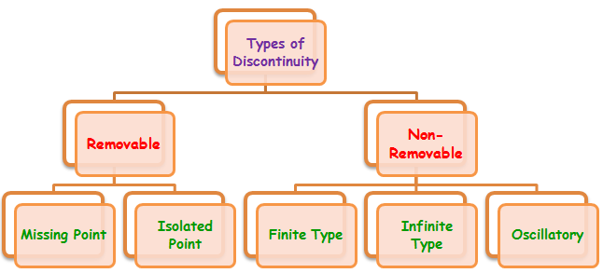Continuous means the graph have no "breaks", "gaps" or "holes".

Extra: Sketch the graphs of each of the five types (google)

For the following function, use the “fail” test table to indicate the continuous, and discontinuous points.

|  |  |  |  |  |
| --- | --- | --- | --- | --- |
|  | x = c | Limit does not exist | Function is not defined | Limit does not equal Function |
| x = 0 |  |  |  |
| x = 1 |  |  |  |
| x = 2 |  |  |  |
| x = 3 |  |  |  |
| x = 4 |  |  |  |
|  |  |  |  |  |
| x=-1 |  |  |  |
| x = 0 |  |  |  |
| x = 1 |  |  |  |
| x = 2 |  |  |  |
| x = 3 |  |  |  |

Sketch a possible graph for a function f that has the stated properties.

* f (1) has a nonremovable discontinuity.
* f (2) exists, $\lim_{x→2^{+}}{f(x)}=f(2)$, but $\lim_{x→2^{-}}{f\left(x\right)=DNE}$
* f (3) exists but $\lim_{x→3}{f(x)}$) does not.
* f (4) exists, $\lim_{x→4}{f(x)}$ exists, but f is not continuous at x = 4.

Determine if $f(x)=\left\{\begin{aligned}\frac{x^{2}+5x-14}{x-2} if x≠2 \\ 12 if x=2\end{aligned}\right\}$ is continuous at x =2. Explain why or why not.

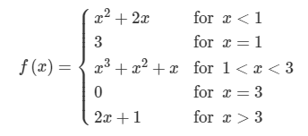 Determine if the function f(x) is continuous at x = 1, 2, 3, 4

For what value of k is the function $g(x)=\left\{\begin{matrix}x^{2}+5x , if x≤3 \\ 2x-kx , if x>3\end{matrix}\right.$ continuous ?

$ f(x) = \cases{ \ \ \ \ Ax - B \ ,& if $\space x \le -1 $\space \cr
2x^2 + 3A...
...f $ -1 < x \le 1 $\space \cr
\ \ \ \ \ \ \ \ 4 \ \ \ ,& if $ x > 1 $\space } $

$ f(x) = \cases{ A^2 x - A \ ,& if $\space x \ge 3 $\space \cr
\ \ \ \ \ \ 4 \ \ \ ,& if $ x < 3 $\space } $

State the intervals over which a function is continuous

a. y = $\frac{1}{x}$ b. y = $\frac{x^{2}+5}{x-2}$ c. y = | x| d. y = sin (x) (radian)

e. y = $\frac{x^{2}+x-6}{x^{2}-4}$ f. y = $\sqrt{xcosx}$ g. y = tan(x) h. y = $\frac{sinx}{x}$

i. y = $\left\{\begin{matrix}\frac{x^{2}-1}{x-1}, x≠1 \\ 2 , x=1\end{matrix}\right.$ j y = $\left\{\begin{matrix}\frac{x^{2}-16}{x^{2}-3x-4}, x≠-1,4 \\ 2 , x=4\end{matrix}\right.$

Continuity versus Having a limit

If a function is *continuous* at a point → It is having a *limit* at this point

If a function is having a *limit* at a point → It may or *may not continuous* at this point

Give example by graph and algebra

continuous and limit limit but discontinuity

Determine the limit and continuity of the following at the given point (feel free to online)

$\lim_{x→3}\frac{{2x}^{2}-6x}{x^{2}-9}$ $\lim_{x→-2}\frac{x^{2}+3x+1}{x^{2}+4x+4}$

$\lim_{x→0}\frac{∣x∣}{x}$ $\lim_{x→3}\frac{\sqrt{x^{2}+4}-2}{x^{2}}$

$\lim_{x→0}\frac{{(3+x)}^{2}-9}{x}$ $\lim_{x→5}\frac{x-5}{\sqrt{x^{2}-25}}$

$\lim_{x→0}\frac{sin3x}{tan3x}$ $\lim_{x→∞}\frac{sinx}{x}$

$\lim_{x→0}\frac{sinx}{x}$ $\lim_{x→0}\frac{sin2x}{x}$

$\lim_{x→0}\frac{sin2x}{x^{2}}$ $\lim_{x→0}\frac{sinx}{\sqrt{x}}$

$\lim_{x→0} xsin\frac{1}{x}$ $\lim_{x→0}\frac{1-cosx}{x}$

$\lim_{x→0}\frac{1-cosx}{x^{2}}$ $\lim_{x→0} sin(x^{2}+1)$

Composite of Continuous Functions: If f is continuous at c and g is continuous at f (c), then the composite g f is continuous at c.

Show that $y=∣\frac{xsin(x)}{x^{2}+2}∣$ is continuous

Let f(x) = g(x) =

Therefore f(g(x)) =

Assessment

Determine if the following function is continuous

at x=1 at x = -2

$ f(x) = \cases{ x^2+2x ,& if $\space x \le -2 $\space \cr
x^3-6x ,& if $ x > -2 $\space } $$ f(x) = \cases{ 3x-5 ,& if $\space x \ne 1 $\space \cr
\ \ \ \ 2 \ \ \ ,& if $ x = 1 $\space } $

at x = 0 at x = -1

$ f(x) = \cases{ \ \ \ \displaystyle{ x-6 \over x-3 } ,& if $\space x < 0 $\spac...
... 2 \ \ \ \ ,& if $ x = 0 $\space \cr
\sqrt{ 4 + x^2 },& if $ x > 0 $\space } $

$ h(x) = \displaystyle{ x^2 + 1 \over x^3+1 } $

State the intervals over which a function is continuous

$ f(x) = \ln \Big( \displaystyle{ x-1 \over x+2 } \Big)$$ f(x) = \sqrt{ x^2 - 2x } $

